**CS 550 – OPERATING SYSTEM**

**PROJECT 3**

**Team 15**

Name: Pranav Sahu, B00759670, [psahu1@binghamton.edu](mailto:psahu1@binghamton.edu)

Shrey Jain, B00768030, [sjain13@binghamton.edu](mailto:sjain13@binghamton.edu)

Status of Implementation: Fully working with all test cases passed.

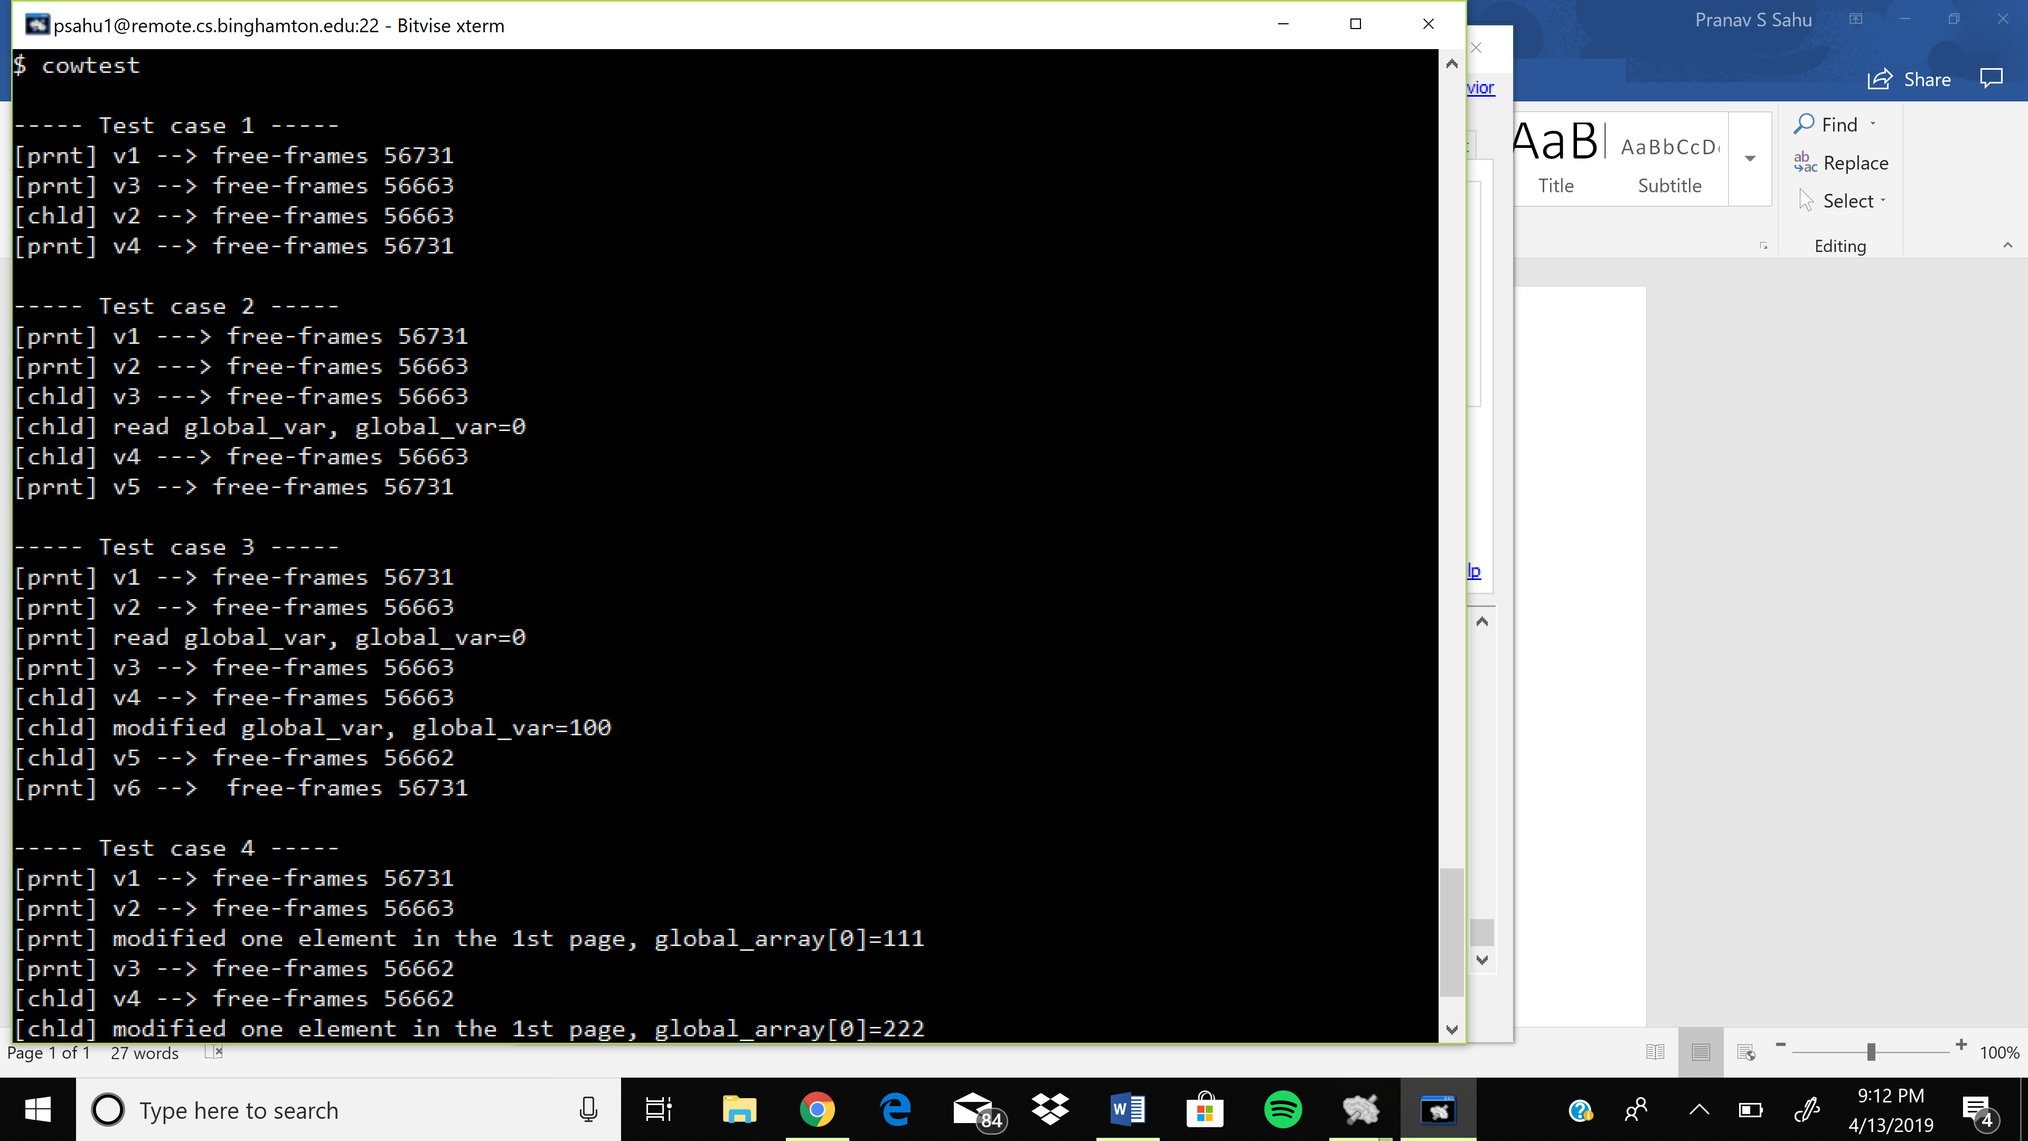

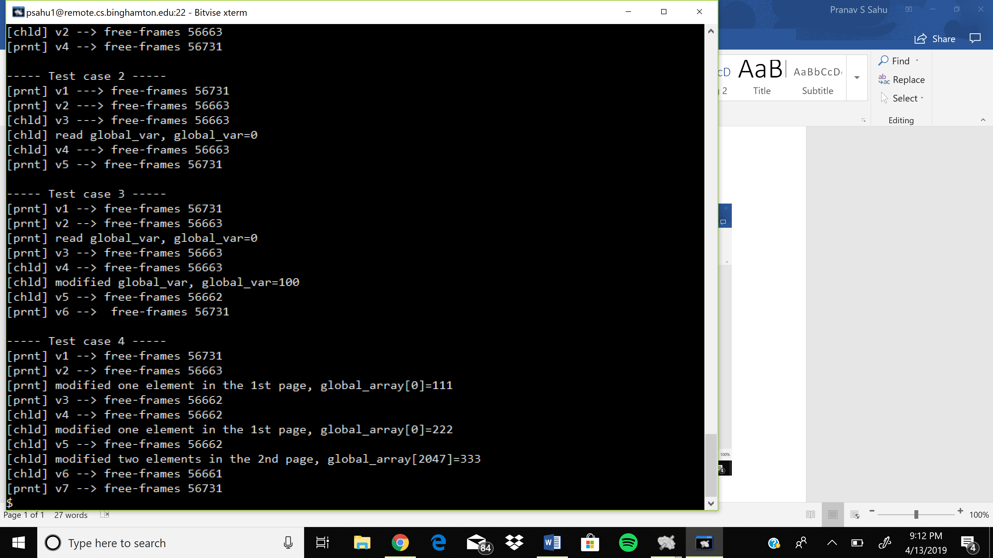

References:

<https://github.com/cristianomj/xv6>

<https://github.com/delphifirst/xv6>

<https://github.com/theSparta/copy-on-write-xv6>